11/4/22, 11:56 PM Untitled2 - Jupyter Notebook

In [2]:

**import** pandas **as** pd

**import** numpy **as** np

**import** matplotlib.pyplot **as** plt

**import** seaborn **as** sns

**import** warnings

warnings.filterwarnings('ignore')

In [4]:

df**=**pd.read_csv('Downloads/Heart_Disease_Prediction.csv')

In [5]:

df.head()

Out[5]:

**Age Sex**

|  |  |  |  |  |  |  |  |  |  |  |  |
| --- | --- | --- | --- | --- | --- | --- | --- | --- | --- | --- | --- |
|  | | | **type** |  |  | **120 res** |  |  |  |  | **flu** |
| **0** | 70 | 1 | 4 | 130 | 322 | 0 | 2 | 109 | 0 | 2.4 | 2 |
| **1** | 67 | 0 | 3 | 115 | 564 | 0 | 2 | 160 | 0 | 1.6 | 2 |
| **2** | 57 | 1 | 2 | 124 | 261 | 0 | 0 | 141 | 0 | 0.3 | 1 |
| **3** | 64 | 1 | 4 | 128 | 263 | 0 | 0 | 105 | 1 | 0.2 | 2 |
| **4** | 74 | 0 | 2 | 120 | 269 | 0 | 2 | 121 | 1 | 0.2 | 1 |

**Chest pain**

**BP Cholesterol**

**FBS**

**over**

**EKG**

**ults**

**Max HR**

**Exercise angina**

**ST**

**depression**

**Slope of ST**

**Numb vesse**

|  |  |  |  |
| --- | --- | --- | --- |
| In | [6]: | | |
| df.isnull().sum() | |  |  |
| Out[6]: | |  |  |
| Age | |  | 0 |
| Sex | |  | 0 |
| Chest pain type | |  | 0 |
| BP | |  | 0 |
| Cholesterol | |  | 0 |
| FBS over 120 | |  | 0 |
| EKG results | |  | 0 |
| Max HR | |  | 0 |
| Exercise angina | |  | 0 |
| ST depression | |  | 0 |
| Slope of ST | |  | 0 |
| Number of vessels | | fluro | 0 |
| Thallium | |  | 0 |
| Heart Disease  dtype: int64 | |  | 0 |

11/4/22, 11:56 PM Untitled2 - Jupyter Notebook

In [7]:

print(df.info())

<class 'pandas.core.frame.DataFrame'> RangeIndex: 270 entries, 0 to 269

Data columns (total 14 columns):

# Column Non-Null Count Dtype

|  |  |  |  |  |  |  |  |  |  |  |
| --- | --- | --- | --- | --- | --- | --- | --- | --- | --- | --- |
| 0 |  | Age |  |  | | 270 | non-null |  | int64 |  |
| 1 |  | Sex |  |  | | 270 | non-null |  | int64 |
| 2 |  | Chest | pain | type | | 270 | non-null |  | int64 |
| 3 |  | BP |  |  | | 270 | non-null |  | int64 |
| 4 Cholesterol | | | | |  | 270 | non-null | int64 | | |
| 5 FBS over 120 | | | | |  | 270 | non-null | int64 | | |
| 6 EKG results | | | | |  | 270 | non-null | int64 | | |
| 7 Max HR | | | | |  | 270 | non-null | int64 | | |
| 8 Exercise angina | | | | |  | 270 | non-null | int64 | | |
| 9 ST depression | | | | |  | 270 | non-null | float64 | | |
| 10 Slope of ST | | | | |  | 270 | non-null | int64 | | |
| 11 Number of vessels | | | | | fluro | 270 | non-null | int64 | | |
| 12 Thallium | | | | |  | 270 | non-null | int64 | | |
| 13 Heart Disease | | | | |  | 270 | non-null | object | | |

dtypes: float64(1), int64(12), object(1) memory usage: 29.7+ KB

None

In [9]:

plt.figure(figsize**=**(20,10))

sns.heatmap(df.corr(), annot**=True**, cmap**=**'terrain')

Out[9]:

<AxesSubplot:>

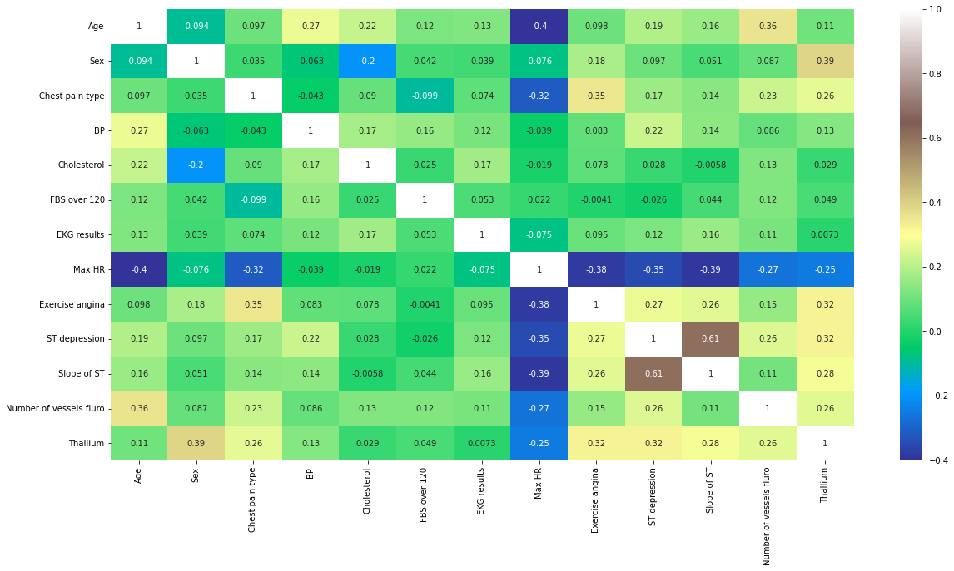

11/4/22, 11:56 PM Untitled2 - Jupyter Notebook

In [10]:

sns.pairplot(data**=**df)

Out[10]:

<seaborn.axisgrid.PairGrid at 0x2059aec2448>

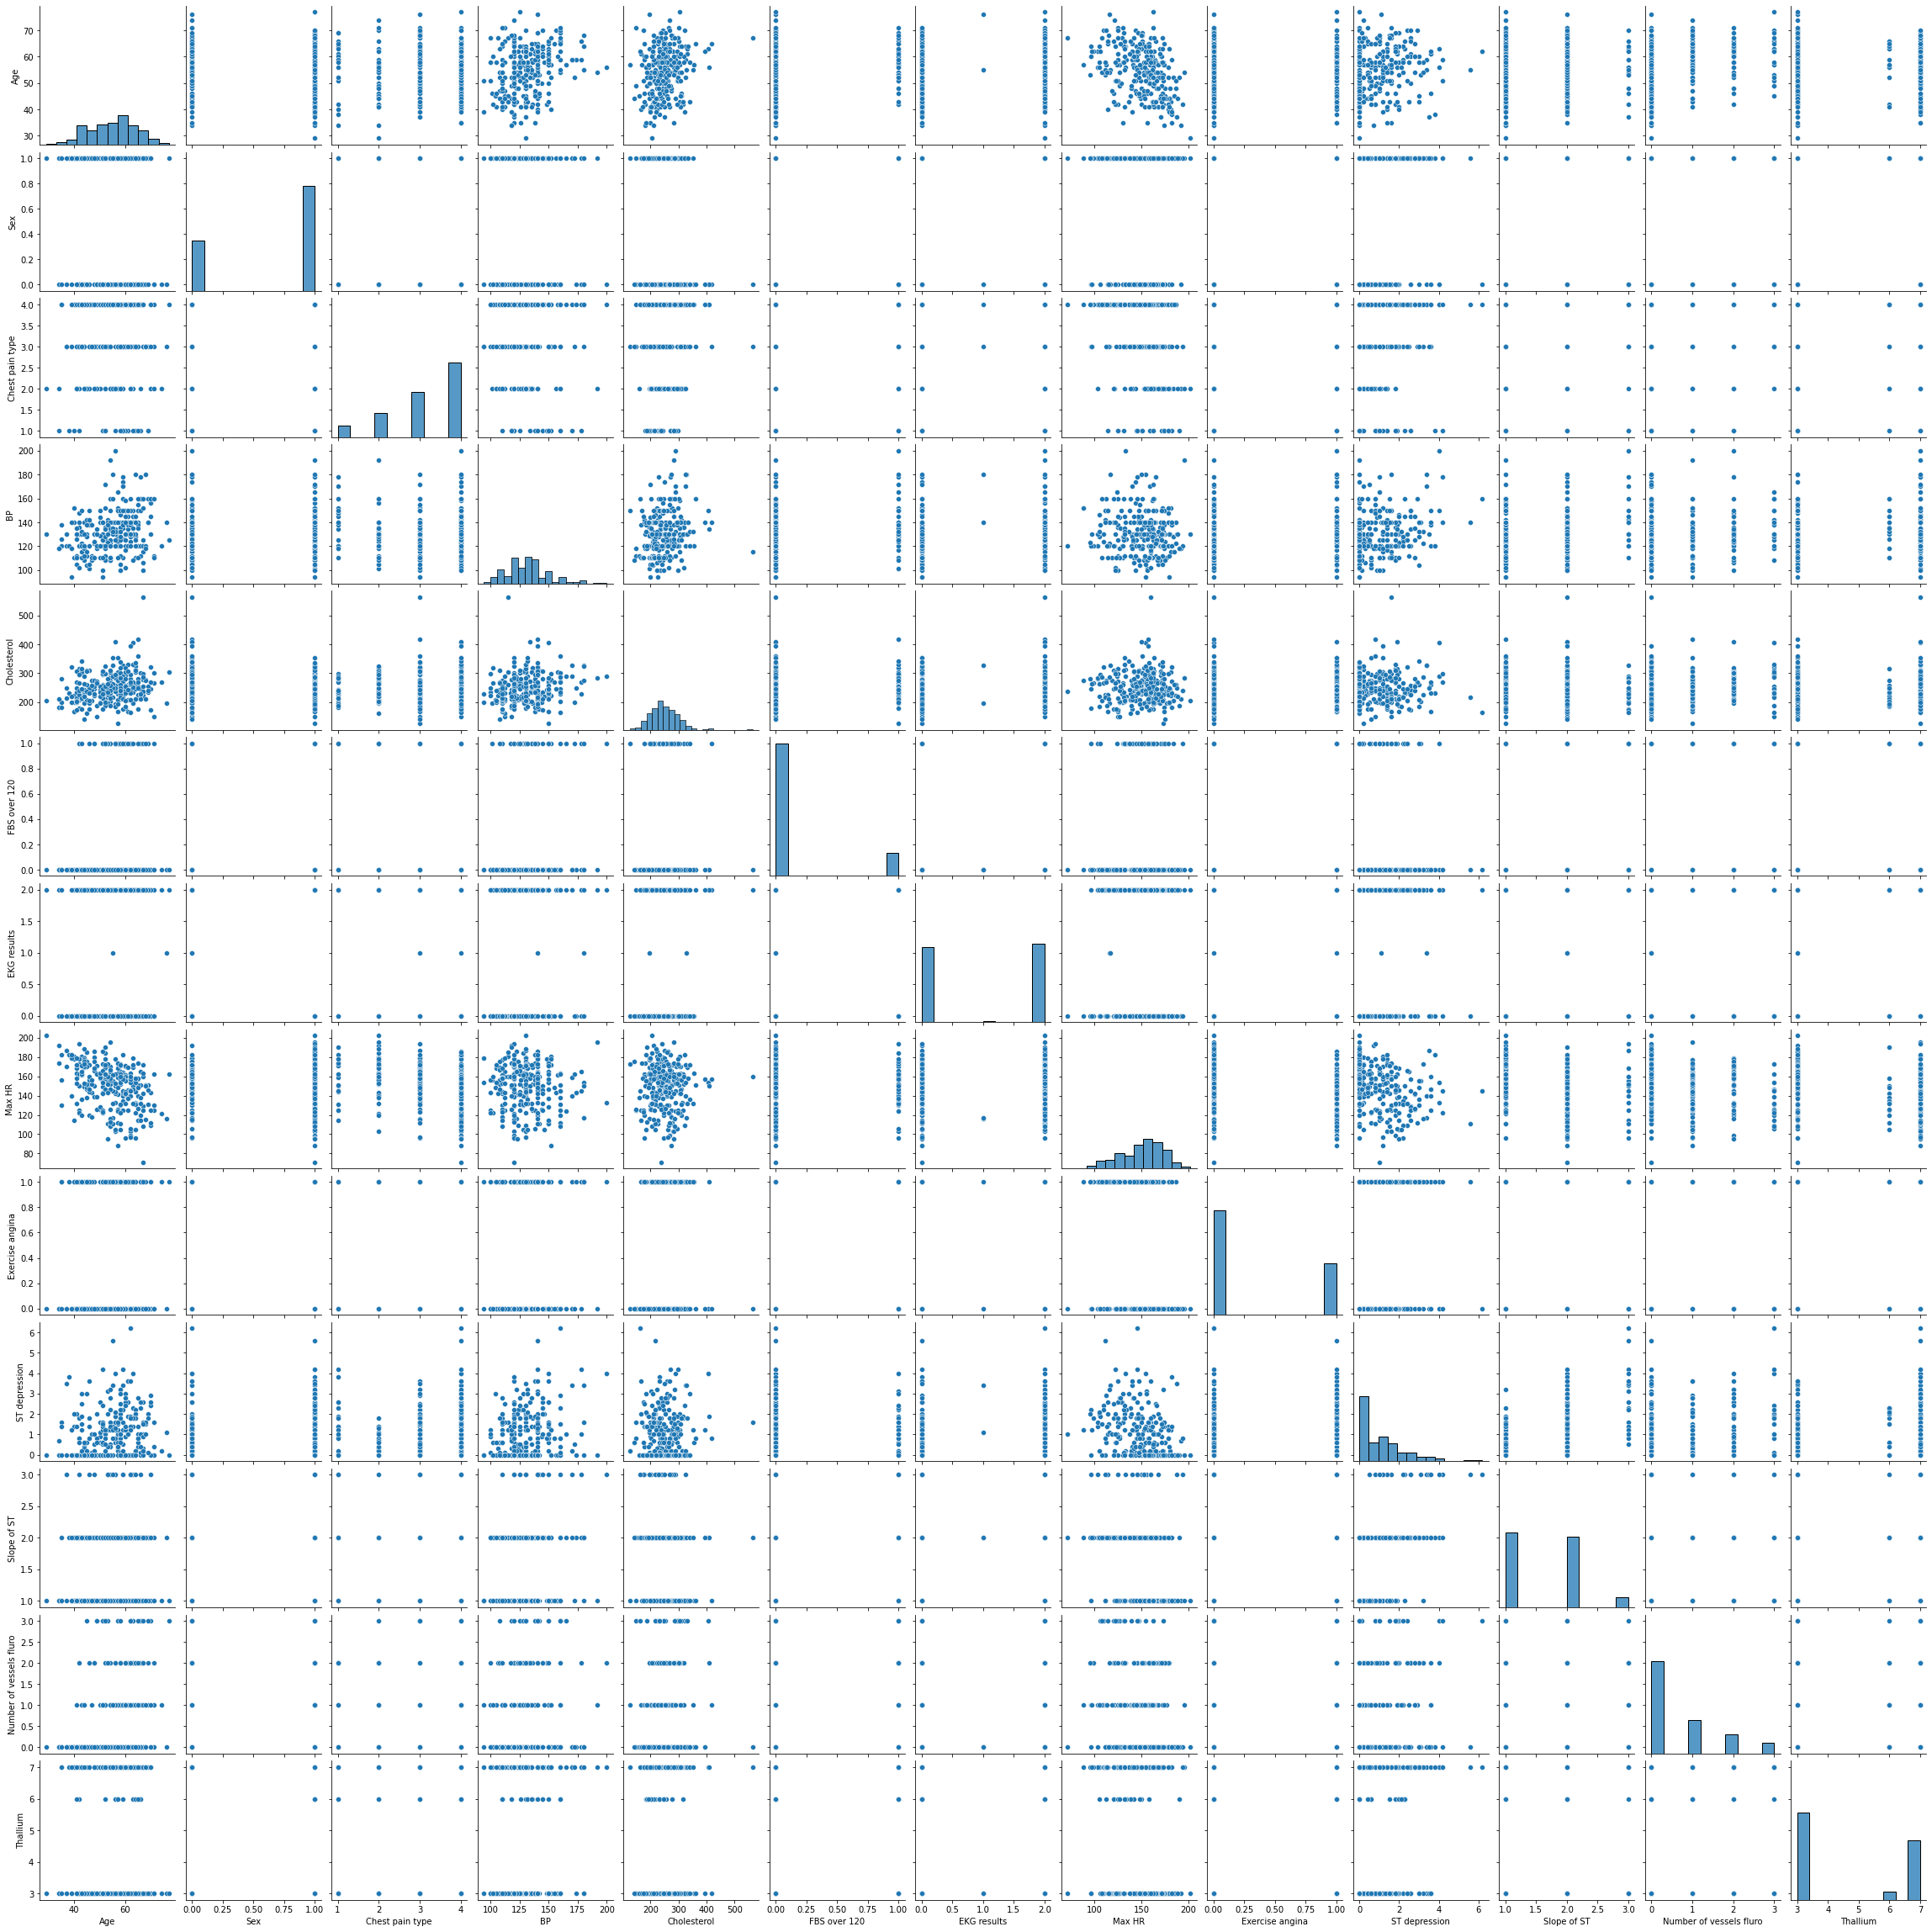

11/4/22, 11:56 PM Untitled2 - Jupyter Notebook

In [11]:

df.hist(figsize**=**(10,12), layout**=**(5,4));

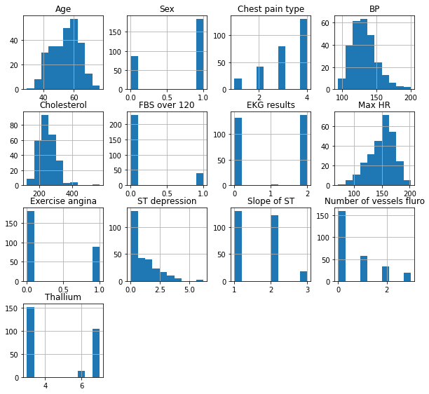

11/4/22, 11:56 PM Untitled2 - Jupyter Notebook

In [13]:

df.plot(kind**=**'box', subplots**=True**, layout**=**(6,3), figsize**=**(10,10)) plt.show()

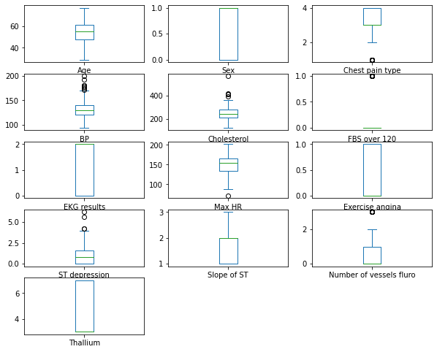

In [ ]: